GUIDED INVESTIGATION QUESTIONS

- WHO KILLED ROLAND GREENE?
WITH Killer AS (
SELECT DISTINCT
s.suspect_id,
s.name,
s.role,
s.relation_to_victim,
s.alibi AS false_alibi,
al.access_time AS vault_access_time,
-- Calculate score
100 AS base_score, -- Vault room access during murder
CASE WHEN s.alibi IN ('At home', 'At hospital', 'Hotel room', 'Left early')
THEN 100 ELSE 0 END AS alibi_lie_score,
CASE WHEN ABS(DATEDIFF(SECOND, al.access_time, '2025-06-01 20:00:00')) < 60
THEN 100 ELSE 50 END AS timing_score
FROM dbo.Suspects s
INNER JOIN dbo.AccessLogs al ON s.suspect_id = al.suspect_id
WHERE al.door_accessed = 'Vault Room'
AND al.success_flag = 1
AND al.access_time BETWEEN '2025-06-01 19:55:00' AND '2025-06-01 20:05:00'
AND s.alibi IN ('At home', 'At hospital', 'Hotel room', 'Left early')
)
SELECT TOP 1
'KILLER IDENTIFIED' AS determination,
suspect_id,
name AS killer_name,
role,
relation_to_victim AS motive_category,
false_alibi AS lied_about_being,
vault_access_time AS actual_crime_scene_access,
DATEDIFF(SECOND, vault_access_time, '2025-06-01 20:00:00') AS seconds_from_murder_time,
(base_score + alibi_lie_score + timing_score) AS total_evidence_score,
-- Evidence
CONCAT(
'1. Accessed Vault Room at ', CONVERT(VARCHAR, vault_access_time, 108),
' | 2. Claimed to be "', false_alibi, '" but was on premises',
' | 3. Access within ', ABS(DATEDIFF(SECOND, vault_access_time, '2025-06-01 20:00:00')), ' seconds of murder',
' | 4. Only suspect with BOTH vault access AND provably false alibi'
) AS evidence_summary
FROM Killer
ORDER BY (base_score + alibi_lie_score + timing_score) DESC;

1. Accessed Vault Room at 20:00:55
2. Claimed to be "At home" but was on premises
3. Access within 55 seconds of murder
4. Only suspect with BOTH vault access AND probably false alibi

- TIME RANGE EVENT HAPPENED
SELECT *
FROM forensic_events_large
WHERE event_description IN ( "Gunshot heard", "Security feed cut");
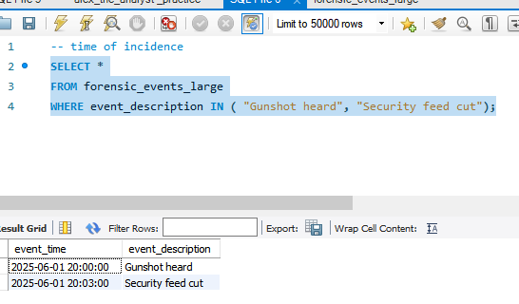

- TOP 3 SUSPECTS
SELECT SL.suspect_id,
SL.name,
SL.alibi,
SL.relation_to_victim,
AL.access_time,
AL.door_accessed,
AL.success_flag,
SL.role
FROM suspects_large SL
JOIN access_logs_large AL ON SL.suspect_id = AL.suspect_id
WHERE access_time BETWEEN "2025-06-01 19:55:00" AND "2025-06-01 20:05:00"
AND door_accessed LIKE "Vault room"
AND AL.success_flag = "True"
ORDER BY access_time ASC;
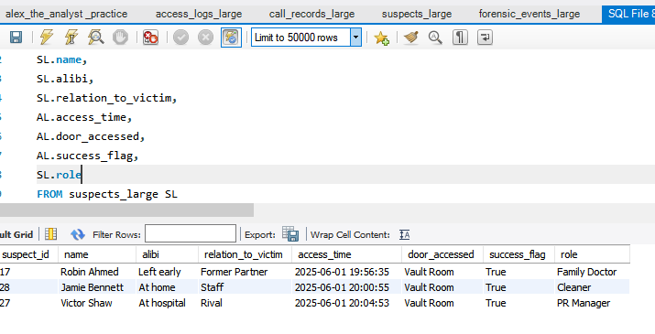

- PEOPLE WHO ACCESSED THE VAULT SHORTLY BEFORE AND AFTER THE INCIDENT (ROBIN AHMED WAS THE LAST TO ENTER BEFORE THE GUN SHOT WAS HEARD AROUND 08:00
SELECT SL.suspect_id,
SL.name,
SL.alibi,
SL.relation_to_victim,
AL.access_time,
AL.door_accessed,
AL.success_flag
FROM suspects_large SL
JOIN access_logs_large AL ON SL.suspect_id = AL.suspect_id
WHERE access_time BETWEEN "2025-06-01 19:55:00" AND "2025-06-01 20:05:00"
AND door_accessed LIKE "Vault room"
AND AL.success_flag = "True"
ORDER BY access_time ASC;
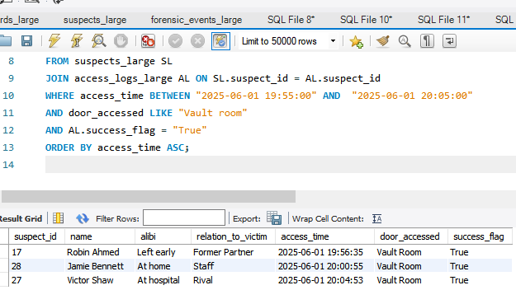

- CALLS MADE IN THE TIMEFRAME AS HE WAS SHOT (SUSAN KNIGHT WITH ID. 5 WAS ON CALL
- WITH THE VICTIM WHEN HE WAS SHOT)
SUSAN KNIGHT
SELECT SL.suspect_id,
SL.name,
CR.call_duration,
CR.recipient_relation,
SL.relation_to_victim,
CR.call_time,
CR.call_duration
FROM suspects_large SL
JOIN call_records_large CR ON SL.suspect_id = CR.suspect_id
WHERE CR.call_time BETWEEN "2025-06-01 19:55:00" AND "2025-06-01 20:05:00";
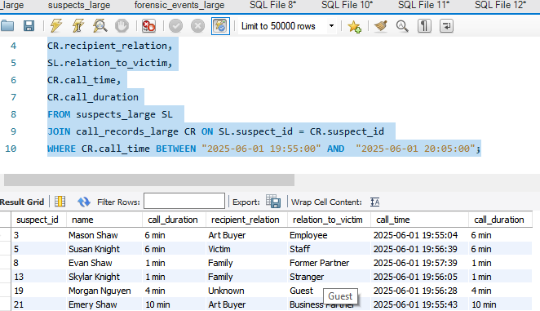
- PEOPLE WHO ENTERED THE VAULT AROUND TIME FRAME WHICH HE RECEIVED A CALL NOTE: LAST PERSON TO ENTER BEFORE THE GUNSHOT SOUND WAS HEARD AROUND 20:00:00 WAS ROBIN AHMED WHILE AFTER WAS JAMIE BENETT AROUND 20:00:55 BUT ACCORDING TO FORENSIC TIMELINE, MOTION WAS DETECTED IN THE VAULT HALLWAY AROUND 20:01, WHICH IS ALSO CLOSER THE PERIOD JAMIE BENETT ENTERED THE VAULT ROOM 20:00:55
SELECT
AL.suspect_id,
AL.access_time,
SL.name,
SL.alibi,
SL.relation_to_victim,
SL.role
FROM access_logs_large AL
JOIN suspects_large SL ON AL.suspect_id = SL.suspect_id
WHERE access_time BETWEEN "2025-06-01 19:55:00" AND "2025-06-01 20:05:00"
AND door_accessed = "Vault room";
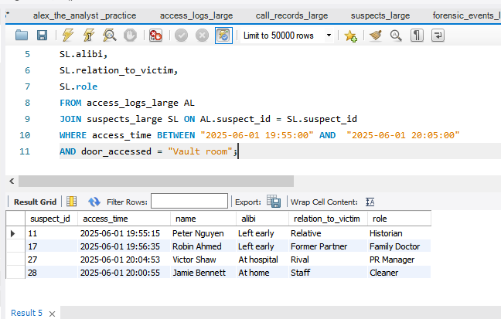

- What does the forensic timeline say about the time and manner of death?

- Which suspect’s movement pattern overlaps with critical time window

WITH MovementTiming AS (
SELECT
s.suspect_id,
s.name,
al.access_time,
al.door_accessed,
al.success_flag,
LAG(al.access_time) OVER (PARTITION BY s.suspect_id ORDER BY al.access_time) AS prev_time,
DATEDIFF(SECOND,
LAG(al.access_time) OVER (PARTITION BY s.suspect_id ORDER BY al.access_time),
al.access_time
) AS seconds_between_movements
FROM dbo.Suspects s
INNER JOIN dbo.AccessLogs al ON s.suspect_id = al.suspect_id
WHERE al.access_time BETWEEN '2025-06-01 19:45:00' AND '2025-06-01 20:15:00'
)
SELECT
suspect_id,
name,
access_time,
door_accessed,
success_flag,
seconds_between_movements,
CASE
WHEN seconds_between_movements < 60 THEN 'Very rapid movement (< 1 min)'
WHEN seconds_between_movements < 120 THEN 'Quick movement (< 2 min)'
WHEN seconds_between_movements > 600 THEN 'Long gap (> 10 min)'
ELSE 'Normal pace'
END AS movement_pattern,
CASE
WHEN door_accessed = 'Vault Room' AND access_time BETWEEN '2025-06-01 19:58:00' AND '2025-06-01 20:02:00'
THEN 'CRITICAL: At vault during murder'
WHEN door_accessed = 'Vault Room'
THEN 'Vault access'
ELSE 'Other locations'
END AS location_risk
FROM MovementTiming
WHERE seconds_between_movements IS NOT NULL
ORDER BY
CASE WHEN door_accessed = 'Vault Room' THEN 0 ELSE 1 END,
access_time;

suspect_id | name | access_time | door_accessed | success_flag | seconds_between_movements | movement_pattern | location_risk
16 | Casey Shaw | 2025-06-01 19:52:45 | Vault Room | 0 | 89 | Quick movement (< 2 min) | Vault access
28 | Jamie Bennett | 2025-06-01 19:54:40 | Vault Room | 0 | 361 | Normal pace | Vault access
17 | Robin Ahmed | 2025-06-01 19:56:35 | Vault Room | 1 | 150 | Normal pace | Vault access
28 | Jamie Bennett | 2025-06-01 20:00:55 | Vault Room | 1 | 46 | Very rapid movement (< 1 min) | CRITICAL: At vault during murder
27 | Victor Shaw | 2025-06-01 20:04:53 | Vault Room | 1 | 186 | Normal pace | Vault access
23 | Evan Ahmed | 2025-06-01 20:09:14 | Vault Room | 1 | 376 | Normal pace | Vault access
6 | Morgan Smith | 2025-06-01 20:10:09 | Vault Room | 0 | 208 | Normal pace | Vault access
4 | Blake Ahmed | 2025-06-01 20:11:57 | Vault Room | 1 | 740 | Long gap (> 10 min) | Vault access
13 | Skylar Knight | 2025-06-01 19:47:50 | Kitchen | 0 | 32 | Very rapid movement (< 1 min) | Other locations
20 | Avery Rivers | 2025-06-01 19:47:55 | Office | 0 | 80 | Quick movement (< 2 min) | Other locations
3 | Mason Shaw | 2025-06-01 19:49:12 | Office | 1 | 65 | Quick movement (< 2 min) | Other locations
18 | Mason Bennett | 2025-06-01 19:49:39 | Office | 1 | 73 | Quick movement (< 2 min) | Other locations
1 | Morgan Bennett | 2025-06-01 19:50:26 | Garden Exit | 0 | 95 | Quick movement (< 2 min) | Other locations
3 | Mason Shaw | 2025-06-01 19:50:33 | Office | 0 | 81 | Quick movement (< 2 min) | Other locations
30 | Quinn Rivers | 2025-06-01 19:51:32 | Office | 0 | 359 | Normal pace | Other locations
27 | Victor Shaw | 2025-06-01 19:52:36 | Kitchen | 1 | 117 | Quick movement (< 2 min) | Other locations
21 | Emery Shaw | 2025-06-01 19:52:47 | Kitchen | 1 | 19 | Very rapid movement (< 1 min) | Other locations
13 | Skylar Knight | 2025-06-01 19:52:55 | Garden Exit | 0 | 305 | Normal pace | Other locations
6 | Morgan Smith | 2025-06-01 19:53:08 | Office | 1 | 271 | Normal pace | Other locations
3 | Mason Shaw | 2025-06-01 19:54:04 | Library | 1 | 211 | Normal pace | Other locations
25 | Jamie Ahmed | 2025-06-01 19:54:28 | Master Bedroom | 0 | 8 | Very rapid movement (< 1 min) | Other locations
18 | Mason Bennett | 2025-06-01 19:55:00 | Library | 1 | 321 | Normal pace | Other locations
23 | Evan Ahmed | 2025-06-01 19:55:17 | Kitchen | 1 | 580 | Normal pace | Other locations
5 | Susan Knight | 2025-06-01 19:57:12 | Master Bedroom | 0 | 440 | Normal pace | Other locations
1 | Morgan Bennett | 2025-06-01 19:57:46 | Office | 0 | 440 | Normal pace | Other locations
1 | Morgan Bennett | 2025-06-01 19:58:02 | Office | 0 | 16 | Very rapid movement (< 1 min) | Other locations
19 | Morgan Nguyen | 2025-06-01 19:58:03 | Master Bedroom | 1 | 249 | Normal pace | Other locations
3 | Mason Shaw | 2025-06-01 19:58:05 | Kitchen | 1 | 241 | Normal pace | Other locations
23 | Evan Ahmed | 2025-06-01 19:59:06 | Office | 0 | 229 | Normal pace | Other locations
25 | Jamie Ahmed | 2025-06-01 19:59:06 | Library | 1 | 278 | Normal pace | Other locations
18 | Mason Bennett | 2025-06-01 19:59:23 | Garden Exit | 0 | 263 | Normal pace | Other locations
18 | Mason Bennett | 2025-06-01 20:00:03 | Kitchen | 0 | 40 | Very rapid movement (< 1 min) | Other locations
6 | Morgan Smith | 2025-06-01 20:00:05 | Master Bedroom | 1 | 417 | Normal pace | Other locations
28 | Jamie Bennett | 2025-06-01 20:00:09 | Office | 1 | 329 | Normal pace | Other locations
23 | Evan Ahmed | 2025-06-01 20:00:20 | Library | 1 | 74 | Quick movement (< 2 min) | Other locations
18 | Mason Bennett | 2025-06-01 20:00:57 | Kitchen | 1 | 54 | Very rapid movement (< 1 min) | Other locations
27 | Victor Shaw | 2025-06-01 20:01:03 | Master Bedroom | 1 | 507 | Normal pace | Other locations
27 | Victor Shaw | 2025-06-01 20:01:47 | Library | 0 | 44 | Very rapid movement (< 1 min) | Other locations
29 | Alex Shaw | 2025-06-01 20:01:47 | Garden Exit | 0 | 122 | Normal pace | Other locations
10 | Mason Rivers | 2025-06-01 20:01:48 | Garden Exit | 1 | 511 | Normal pace | Other locations
18 | Mason Bennett | 2025-06-01 20:02:19 | Library | 0 | 82 | Quick movement (< 2 min) | Other locations
23 | Evan Ahmed | 2025-06-01 20:02:58 | Office | 0 | 158 | Normal pace | Other locations
29 | Alex Shaw | 2025-06-01 20:03:01 | Kitchen | 0 | 74 | Quick movement (< 2 min) | Other locations
11 | Peter Nguyen | 2025-06-01 20:03:01 | Kitchen | 1 | 466 | Normal pace | Other locations
7 | Susan Knight | 2025-06-01 20:03:36 | Garden Exit | 1 | 54 | Very rapid movement (< 1 min) | Other locations
17 | Robin Ahmed | 2025-06-01 20:03:51 | Master Bedroom | 0 | 436 | Normal pace | Other locations
9 | Jamie Knight | 2025-06-01 20:04:46 | Office | 0 | 1158 | Long gap (> 10 min) | Other locations
22 | Peter Bennett | 2025-06-01 20:05:23 | Library | 0 | 1204 | Long gap (> 10 min) | Other locations
7 | Susan Knight | 2025-06-01 20:05:28 | Master Bedroom | 0 | 112 | Quick movement (< 2 min) | Other locations
16 | Casey Shaw | 2025-06-01 20:05:40 | Kitchen | 1 | 775 | Long gap (> 10 min) | Other locations
7 | Susan Knight | 2025-06-01 20:06:16 | Kitchen | 1 | 48 | Very rapid movement (< 1 min) | Other locations
6 | Morgan Smith | 2025-06-01 20:06:41 | Kitchen | 0 | 396 | Normal pace | Other locations
11 | Peter Nguyen | 2025-06-01 20:07:08 | Library | 0 | 247 | Normal pace | Other locations
19 | Morgan Nguyen | 2025-06-01 20:07:38 | Master Bedroom | 1 | 575 | Normal pace | Other locations
16 | Casey Shaw | 2025-06-01 20:08:46 | Kitchen | 0 | 186 | Normal pace | Other locations
7 | Susan Knight | 2025-06-01 20:09:01 | Office | 1 | 165 | Normal pace | Other locations
8 | Evan Shaw | 2025-06-01 20:09:30 | Garden Exit | 1 | 1216 | Long gap (> 10 min) | Other locations
6 | Morgan Smith | 2025-06-01 20:10:22 | Library | 1 | 13 | Very rapid movement (< 1 min) | Other locations
29 | Alex Shaw | 2025-06-01 20:10:24 | Office | 0 | 443 | Normal pace | Other locations
30 | Quinn Rivers | 2025-06-01 20:10:33 | Master Bedroom | 0 | 1141 | Long gap (> 10 min) | Other locations
8 | Evan Shaw | 2025-06-01 20:10:57 | Office | 0 | 87 | Quick movement (< 2 min) | Other locations
24 | Nina Smith | 2025-06-01 20:11:07 | Master Bedroom | 0 | 850 | Long gap (> 10 min) | Other locations
19 | Morgan Nguyen | 2025-06-01 20:11:55 | Kitchen | 1 | 257 | Normal pace | Other locations
30 | Quinn Rivers | 2025-06-01 20:12:01 | Kitchen | 0 | 88 | Quick movement (< 2 min) | Other locations
9 | Jamie Knight | 2025-06-01 20:12:28 | Kitchen | 1 | 462 | Normal pace | Other locations
3 | Mason Shaw | 2025-06-01 20:12:34 | Library | 0 | 869 | Long gap (> 10 min) | Other locations
20 | Avery Rivers | 2025-06-01 20:12:47 | Library | 1 | 1492 | Long gap (> 10 min) | Other locations
12 | Robin Shaw | 2025-06-01 20:12:50 | Garden Exit | 0 | 321 | Normal pace | Other locations
11 | Peter Nguyen | 2025-06-01 20:13:42 | Master Bedroom | 1 | 394 | Normal pace | Other locations
18 | Mason Bennett | 2025-06-01 20:13:45 | Library | 1 | 686 | Long gap (> 10 min) | Other locations
29 | Alex Shaw | 2025-06-01 20:13:46 | Garden Exit | 0 | 202 | Normal pace | Other locations
14 | Samira Shaw | 2025-06-01 20:14:55 | Garden Exit | 1 | 1375 | Long gap (> 10 min) | Other locations

- How do the data sources contradict or confirm one another?

